English / Portuguese / French / Thai / Vietnamese / Spanish

영어

Brief:
An email sent to partners who have attended the event. This email will include a photo gallery It will be sent via customer.io

Target audience:
이벤트 참석자

Subject: Thank you for coming to [EVENT NAME]!

저희 행사를 성공적으로 이끌어 주셨습니다! 🎉

Hi [PARTNER NAME],

Thank you for attending [EVENT NAME] in [CITY], [COUNTRY]. 즐거운 시간 되셨기를 바라며, 여러분을 알게 되어 기뻤습니다!

For pictures and highlights from the conference/seminar/affiliate trip and to stay updated on our latest events and initiatives for you, follow us on:

 | 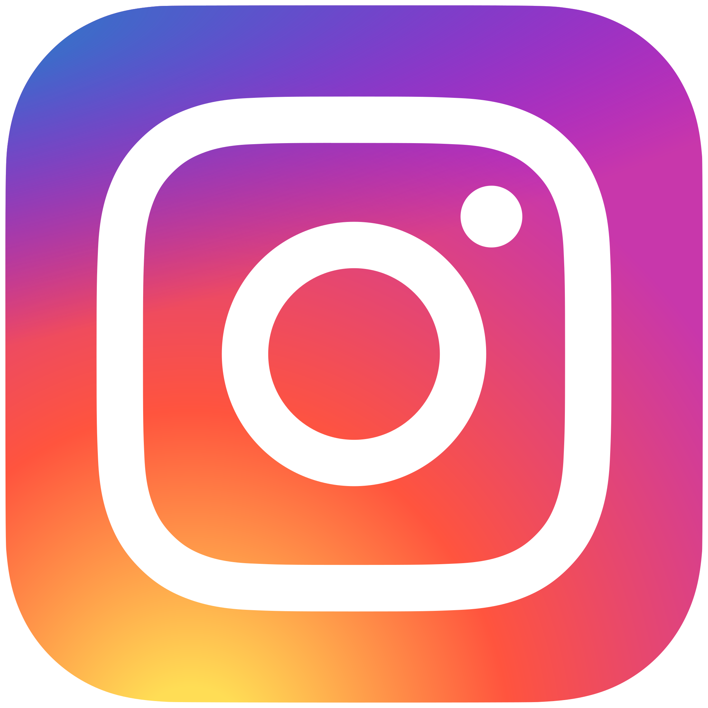 | 
이번 행사가 저희만큼이나 여러분에게도 많은 영감을 주었기를 바라며, 함께 성장해 나갑시다!

